20IT4303: ADVANCED DATA STRUCTURES & ALGORITHMS
HOME ASSIGNMENT-3 QUESTIONS
A.Y:2021-22
S.NO | QUESTION | COURSE OUTCOME | BTL
2 | 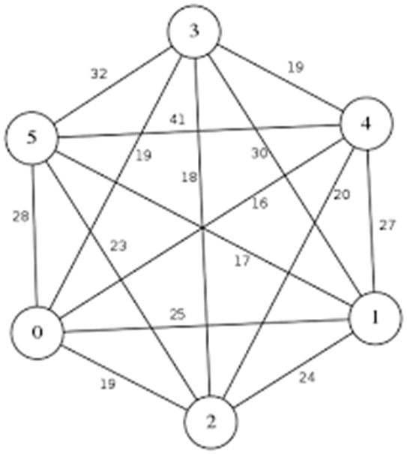  Solve the problem as Travelling Salesperson Problem to find the optimal route using dynamic programming with ‘0’ as the starting point. | CO3 | Apply
7 | 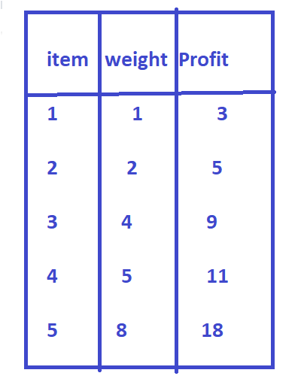  Solve the problem as 0/1 Knapsack problem to find the optimal solution using dynamic programming | CO3 | Apply
14 | Design a four stage system with device types D1, D2, D3, D4. The costs are Rs.40, Rs.20 Rs.15 and Rs.25 respectively. The cost of the system is to be no more than Rs.195. The reliability of each device type is 0.9, 0.8 and 0.5 respectively. | CO3 | Apply
19 | 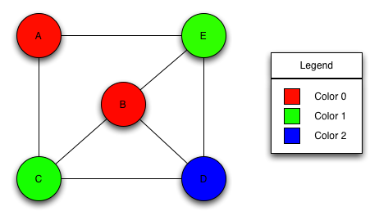  Identify any three ways of coloring the graph with Red, Green and Blue colors. | CO2 | Apply
24 | Solve the following sum of subsets problem using backtracking.  N= 6, W = (2, 3, 4, 5, 12, 15) M = 30 | CO2 | Apply

Regd.No | Question Number | Regd.No | Question Number | Regd.No | Question Number
208W1A1277 | 2,7,14,19,24 | 208W1A1299 | 2,7,14,19,24 | 208W1A12C3 | 2,7,14,19,24

